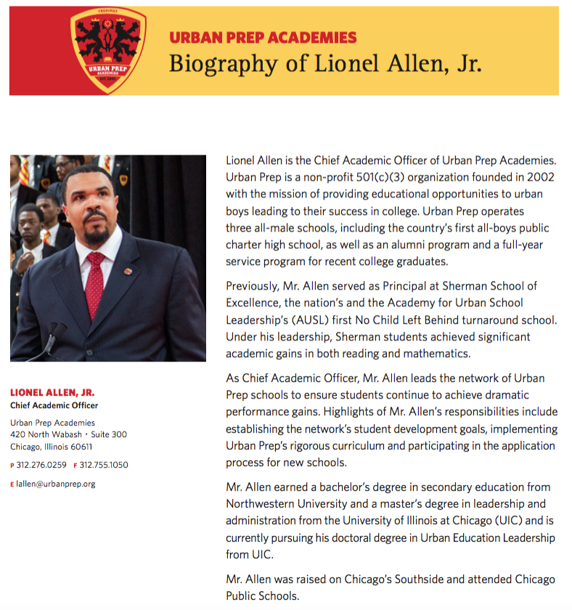
Presenters and Facilitators

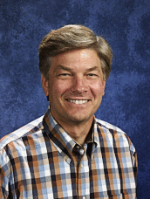
John Booy graduated from Calvin College in 1974 with a Bachelor of Arts degree in Elementary Education, with majors in Psychology and Sociology. Following graduation, he began teaching for the Grand Rapids Public Schools at Beckwith Elementary. He received his Masters of Arts degree in Teaching from Calvin College in 1981 and co-founded The Potter's House School in the fall of 1981. Mr. Booy continued to teach at Beckwith Elementary while serving, for the first few years, as the volunteer administrator for The Potter's House. In 2002, Mr. Booy left the GRPS to dedicate himself full time to The Potter's House, working as administrator and superintendent.

John is a frequent speaker on issues surrounding urban education, Christ-centered education, and diversity. His involvement and experience in these issues led him to deliver testimony in front of the 1995 United States Senate Subcommittee on Children and Families hearing on “Private Efforts to Reshape America.” Mr. Booy is an active member of Mars Hill Bible Church. He is also the father of two boys adopted from India.

----------------------

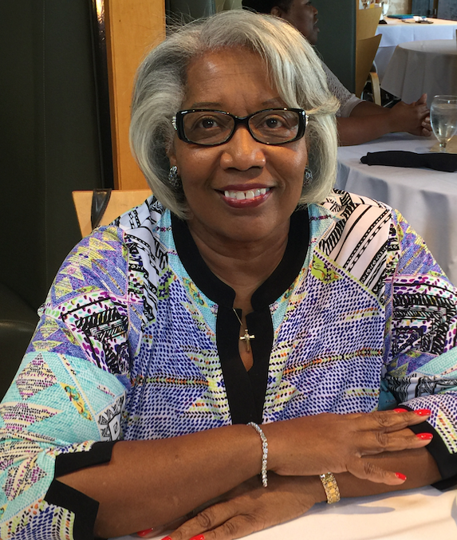
Glenda Harvey earned a degree in elementary education from Tennessee State University. After graduation she moved to Detroit. MI where she served in Detroit Public Schools as an elementary school principal, assistant principal, and teacher. In 1992 she founded City Day School of Detroit, a Christian school. She established The Veritas Group Enterprise, LLC which is an educational consulting group. VGE provides educational services to schools as requested by clients. Glenda is blessed to the mother of two sons, a daughter-in-law, two grandsons and connected to many students who remain in her life. She is presently active in educational consulting, volunteering at her church and helping parents chart an educational path for their children.

-------------------------
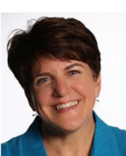
Tami Doig has been involved at Daystar School for over 15 of its 19 years, as a parent, board member, teacher, and now its second principal. Tami has worked in urban education her entire career, and believes it’s potential to transform lives and thus culture is reason for great hope! She lives a few blocks from Daystar with her husband Dave and (when in between school and grown-up apartments) their two nearly-grown children. Tami earned her BA in Christian Education from Wheaton College and a M.A. in Early Childhood Education from Concordia University Chicago. She has mentored students from middle school through college, taught at the college level, and is currently completing her dissertation for a Ph.D. in education from Concordia University Chicago.
-------------------------
-------------------------
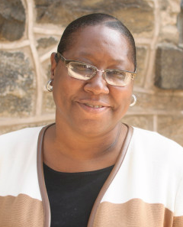
Stephanie Hook joined The City School family as a parent in 1990, choosing to send her sons here to receive a rigorous education rooted in the glory of God. She quickly fell in love with our mission, began volunteering regularly, and was hired as our fifth grade teacher in 1998. Four years later she was promoted to elementary and middle school principal, where she has been faithfully serving ever since. Stephanie is very active in her church and community, and in her spare time she enjoys reading classics such as The Pilgrim’s Progress.

-------------------------

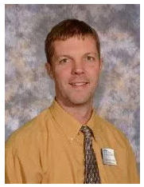
Mark Ponstine has been serving as preK thorugh 8th grade administrator at the Potter's House school for the past eight years. Prior to that Mark taught mathematics, Bible, and technology classes to middle school students and also gave leadership to a middle school team of teachers. Mark earned a mathematics and secondary education degree from Calvin College ('98) and later a master’s degree in educational technology and instructional design from Michigan State University ('02). When time allows Mark is spending time outdoors, camping with his wife and three children, and reading a wide variety of books.

-------------------------

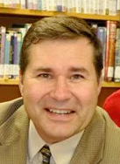
Russ Gregg (B.A., Global Studies, University of Wisconsin-Madison) has served as Head of School since Hope Academy’s founding in 2000. He has been a resident of the Phillips neighborhood since 1994. In 1999, he was an administrator at Calvin Christian School in Edina, and quit his job to help lay the groundwork for a Christian school for his urban neighbors. Russ and his wife Phyllis, who teaches 3rd grade at Hope Academy, live four blocks away from the school. They have three grown children. Russ serves on the Board of Directors of the Society for Classical Learning.

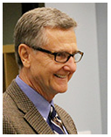
Dave Larsen began his professional career in youth ministry, served Trinity Christian College as Vice President for Student Development for nearly twenty years, and Timothy Christian Schools as its Director of Development for twelve years. Now as Director of the Bright Promise Fund for Urban Christian Education he delights in raising funds for scholarships and tuition assistance for its network of schools. Dave is a graduate of Calvin College (BA English), Trinity Evangelical Divinity School (Masters of Religious Education) and earned a PhD in Educational Leadership and Policy Studies at Loyola University Chicago.

-------------------------

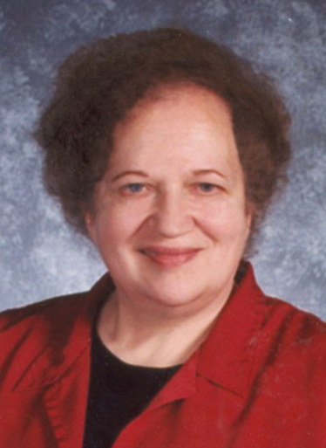
Harriet Potoka serves as the Director of C-CUE, the Center for Christian Urban Educators. She assumed this position after serving as the founding principal of Daystar School for16 years. Prior to her leadership role at Daystar she served as the principal of Sylvan Christian School in Grand Rapids, MI, as curriculum director and principal of Calvin Christian School in Mpls. MN and as a classroom teacher in Mpls, and Sioux Falls, SD. Harriet received her BA in Elementary Education from Dordt College and her MEd in school administration from St. Thomas University in St. Paul, MN. Harriet is passionate about encouraging and supporting Christian educators serving in urban settings as they provide urban children with authentic, excellent learning opportunities.

-------------------------

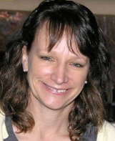
Laurel Christensen is a Senior Fellow and the Director of the Scholarships for Education Choice program at Sagamore. Laurel joined Sagamore as a Research Fellow working in operations and assisting StreetSchool Network schools on their improvement processes and accreditation. After graduating from Trinity Western University with a degree in History, Laurel went to work in the corporate world in human resources and then started a family. She went on to complete her teacher certification at Calvin College and taught high school for 10 years at the Potters House High school, a school devoted to serving the needs of diverse students. While teaching she went on to earn her master’s in education from Grand Valley State University. She continued her work in education by serving as the Director of School Development for the StreetSchool Network™ and worked on the team that developed and coached schools using the Infusionomics program.

