School Culture Resources

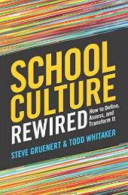
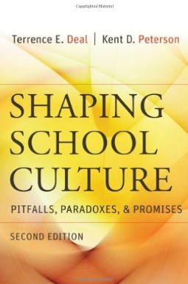
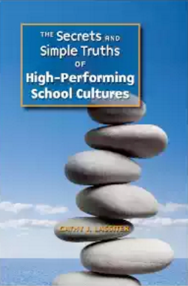

Articles about School Culture

ASCD Lexicon of Learning: School Culture and Climate
http://www.ascd.org/research-a-topic/school-culture-and-climate-resources.aspx

School Culture: The Hidden Curriculum
http://www.readingrockets.org/article/school-culture-hidden-curriculum

Why School Culture Matters and How to Improve It
http://www.huffingtonpost.com/Michael-Haberman/why-school-culture-matter_b_3047318.html

How Schools Can Build Cultures Where Teachers and Students Thrive
http://tntp.org/assets/documents/TNTP_Greenhouse_Schools_2012.pdf

The Effects of School Culture and Climate on Student Achievement
http://donnieholland.wiki.westga.edu/file/view/school+culture+climate+%26+achievement.pdf

10 Characteristics of Great School Cultures
http://gettingsmart.com/2013/09/10-characteristics-of-high-performance-culture/

How Leaders Grow a Positive School Culture
http://www.middleweb.com/26167/how-leaders-grow-a-positive-school-culture/
Programs Used to Build School Culture

Responsive Classroom
https://www.responsiveclassroom.org/
Daystar School, Chicago, IL: Tami Doig
City School, Philadelphia, PA: Stephanie Hook
Mustard Seed School, Hoboken,NJ: Tom Postema

Capturing Kids’ Hearts
http://flippengroup.com/solutions/capturing-kids-hearts/
Potter’s House, Grand Rapids, MI: Mark Ponstine,
Hope Academy, Minneapolis, MN: Russ Gregg

PBIS: Positive Behavioral Interventions and Supports
https://www.pbis.org/school

Sample Rubrics to Assess School Culture

North Star
http://tntp.org/assets/tools/NSA-USI%2010-11+School+Culture+Rubric+FINAL%20TSLT_0311.pdf

Turnaround Principle #2: School Climate and Culture
http://www.doe.in.gov/sites/default/files/turnaround-principles/turnaround-principles-rubric-tp-2.pdf

Book Reviews and Activities

Building Community in Schools by Thomas Sergiovanni
http://hepg.org/her-home/issues/harvard-educational-review-volume-66-issue-4/herarticle/_251

Shaping School Culture by Terrence E. Deal and Kent D. Peterson
(Printed copy in packet)

The Secrets and Simple Truths of High-Performing School Cultures by Cathy J. Lassiter
http://schd.ws/hosted_files/schoolimprovementsummitatla2014/4f/8%20GA%20Atlanta%20SI%20Summit%20School%20Culture%20Matters%20Handout%206.3-5.14%20CLA_Final.pdf

